**Evidence for Implementation & Testing Unit**

Name: Olga Maunsell

Cohort: E18

**I.T. 1 - Encapsulation in a program**

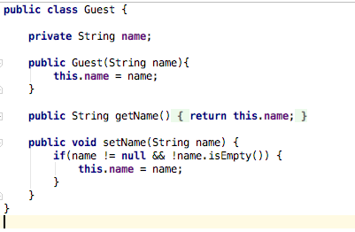

**I.T.2 – Inheritance**

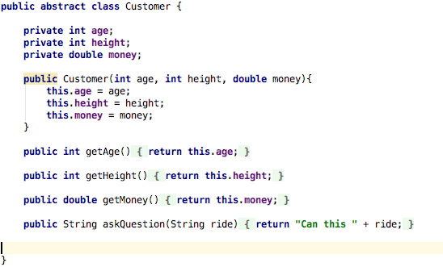

Adult class inherits from Customer class

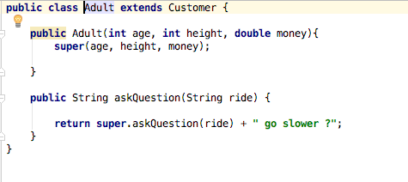

Adult object and .getAge method inherited from Customer class

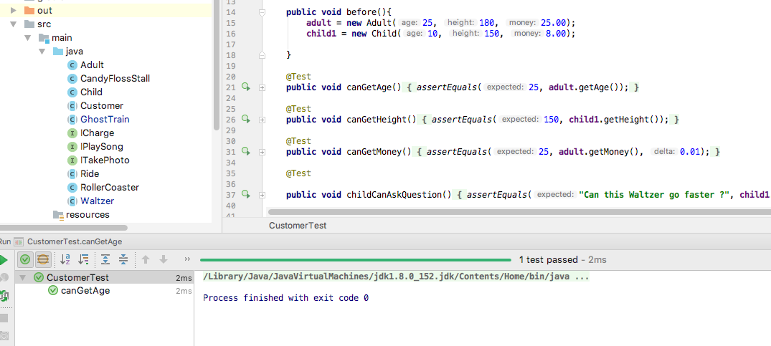

**I.T.3 – Demonstrate searching data in a program**

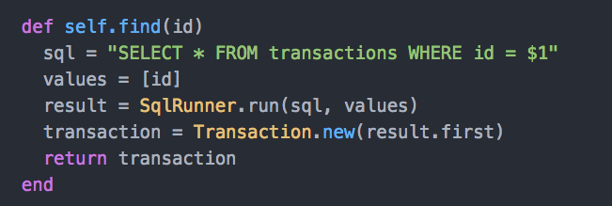

Result of search function running

Screenshot of all transactions

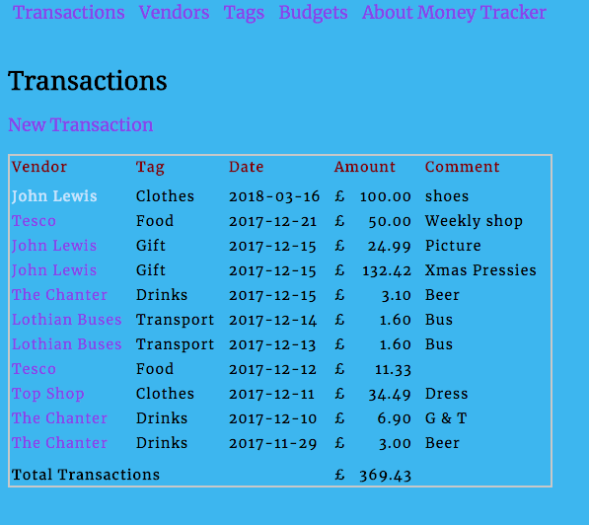

User selects to view 1 transaction and the above search function is then run to produce the result of transaction searched/ found and displayed

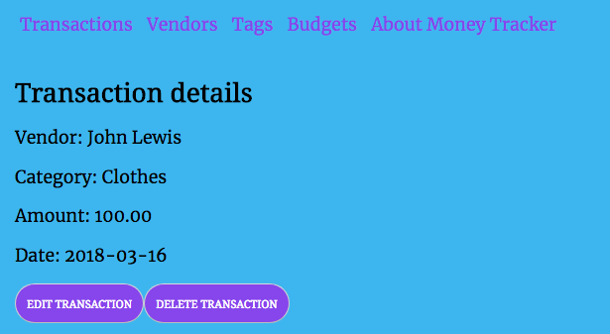

**I.T.4 – Demonstrate sorting data in a program**

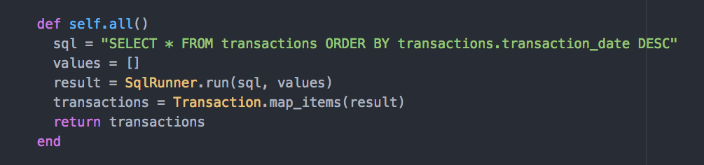

Transactions are retrieved and sorted in descending order to be displayed on the screen in descending order



**I.T 5 – Use of an array in a program**

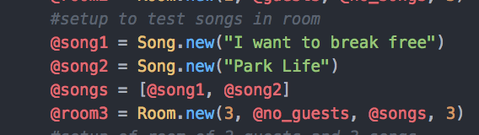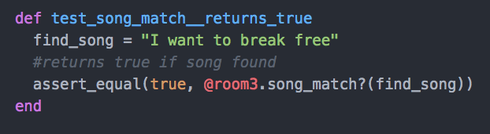

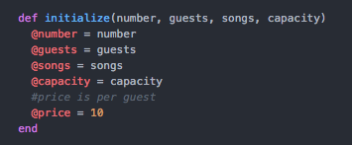

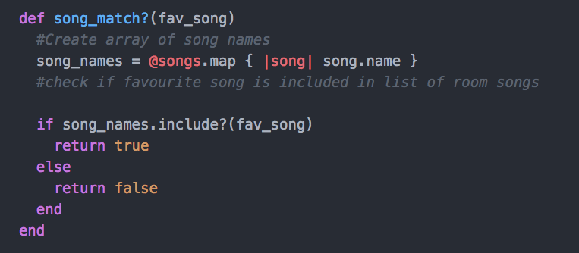

Result of function running

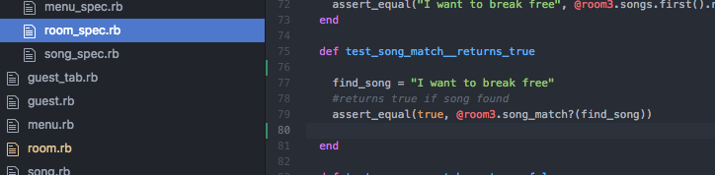

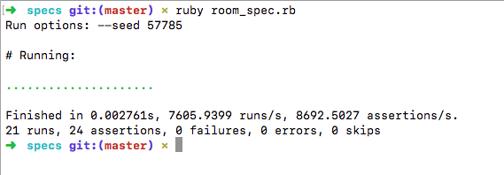

**I.T 6 – Use of a hash in a program**

“admin” hash contained within “pet_shop” hash

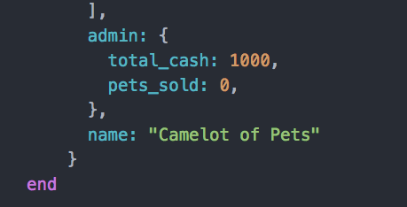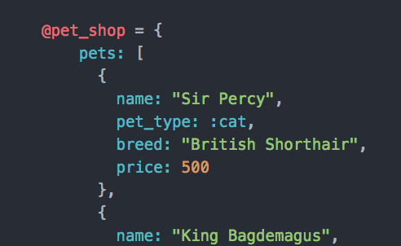

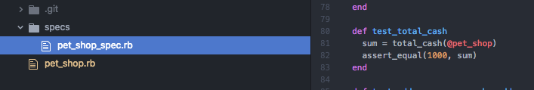

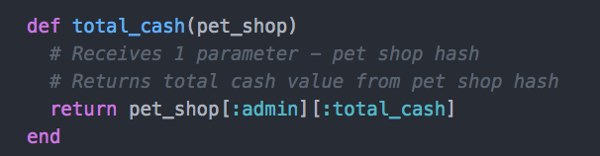

Result of function running

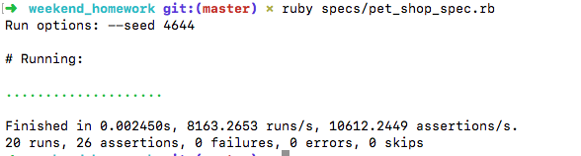

**I.T. 7 – Polymorphism**

1. **Shop class has an ArrayList of ISellable stockItems**

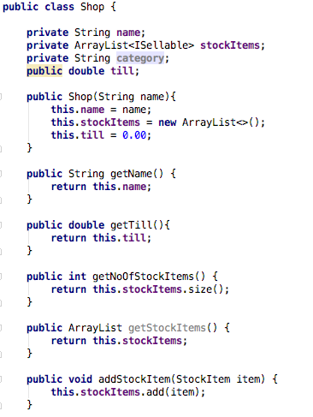

**2. StockItem class implements ISellable interface**

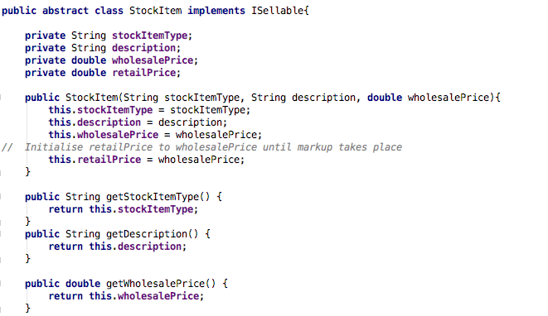

**3. DrumSticks class extends StockItem class and therefore implements ISellable interface**

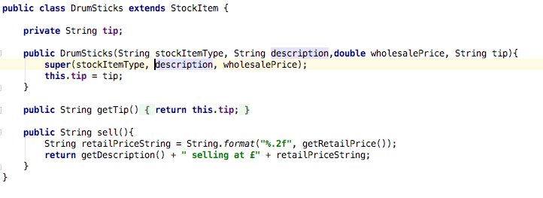

**4. Instrument class extends StockItem class and therefore implements ISellable interface.**

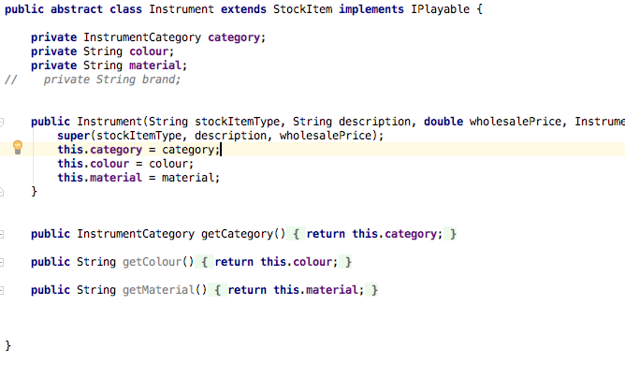

**4. ISellable interface**

